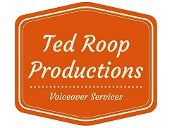 |  | Team Introduction Order Form
Contact Name:
Contact Number:
Contact Email:

Team Name/Age Group:
Sponsor - JERSEY
Sponsor- PUCKS | Apple home builders
Sponsor - Team introductions | D&D ELECTRIC AND ROES ZEHR ELECTRIC
Template number
Roster
Jersey # | Player Name

